

Software Engineering I  
 CS251

**Easily Buy, Sell, Exchange Products web-application**2014

|  |  |  |
| --- | --- | --- |
| **Name** | **ID** | **Group** |
| Ahmed Sayed Eid | 20120030 | CS_1 |
| Ahmed Mohamed Fekry | 20120062 | CS_1 |
| Sherif Mohamed Farouk | 20120207 | CS_1 |
| Mahmoud Mohamed Hadad | 20120364 | CS_1 |
| **TA:** Catherine Bedrossian  Dr.: Mohamed El_Ramly  Git-hub link : |  |  |

Contents

Team 3

Document Purpose and Audience 4

System Models 4

System Decomposition 4

Class diagrams 5

Sequence diagrams 9

Class - Sequence Usage 9

Physical Entity-Relationship Diagram 10

Ownership Report 11

# 

# Team

|  |  |  |  |
| --- | --- | --- | --- |
| **ID** | **Name** | **Email** | **Mobile** |
| 20120364 | Mahmoud Mohamed Hadad | [hooda_fci@yahoo.com](mailto:hooda_fci@yahoo.com) | 01117943793 |
| 20120207 | Sherif Mohamed Farouk | [sfarouk513@gmail.com](mailto:sfarouk513@gmail.com) | 01144967048 |
| 20120030 | Ahmed Sayed Eid | [medo.shahin15@gmail.com](mailto:medo.shahin15@gmail.com) | 01129254603 |
| 20120062 | Ahmed Mohamed Fekry | [ahmedfikry78@gmail.com](mailto:ahmedfikry78@gmail.com) | 0112059041 |

# 

# 

# Document Purpose and Audience

View system description and depicts the overall system decomposition also provide fully detailed class digrams, sequence digrams, and physically entity relation digram.

It fully display and explain every single function to the customer and other developers work on the current project.

# System Models

## System Decomposition

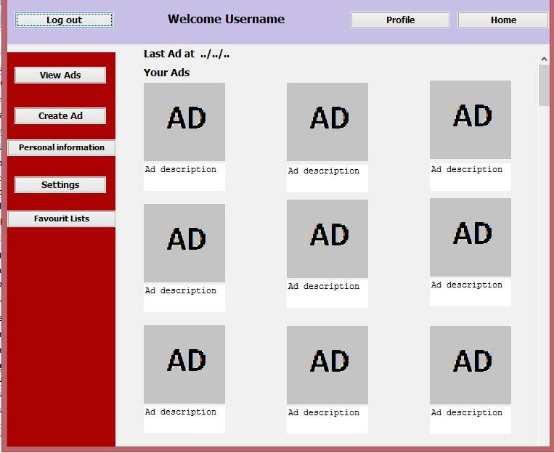

## Class diagrams

|  |  |  |  |
| --- | --- | --- | --- |
| Class ID | Class Name | Subsystem ID | Description |
| 1 | User | **1.1.1 Attributes**  - **ID** : Integer [1]  - **Name** : String [1]  - **Mail** : String [1]  - **Password** : String [1]  null  - **Logged_in** : Boolean [1]  - **location** : String [1]  - **List[]** : List [1]  **1.1.2 Generalizations**  None  **1.1.3 Operations**  - Void **CreateUser** ()  - Void **UpdateUser** ()  - Void **DeleteUser** ()  **1.1.4 Associations**  - **post** : Post [1..*]  - **list** : List [1..*] | Enable the user to create new, update, delete account and to add post or create lists |
| 2 | Post | **1.2.1 Attributes**  - **ID** : Integer [1]  - **CategoryId** : Integer [1]  - **SubCategoryId** : Integer [1]  - **UserId** : Integer [1]  - **ItemId** : Integer [1]  - **Place** : String [1]  **1.2.2 Generalizations**  None  **1.2.3 Operations**  - Void **CreatePost** ()  - Void **DeletePost** ()  - Void **UpdateList** ()  **1.2.4 Associations**  - **user** : User [1]  - **list** : List [0..1]  - **subcategory** : Subcategory [1]  - **item** : Item [1] | Allows the user to create, delete and update post |
| 3 | Subcategory | **1.3.1 Attributes**  - **ID** : Integer [1]  - **Name** : String [1]  - **Description** : String [1]  - **Item[]** : Item [1]  **1.3.2 Generalizations**  None  **1.3.3 Operations**  - Void **CreateSubcategory** ()  - Void **UpdateSubcategory** ()  - Void **DeleteSubcategory** ()  **1.3.4 Associations**  - **category** : Category [1]  - **post** : Post [1..*]  - **item** : Item [*] | Adding subcategories to certain categories |
| 4 | Category | **1.4.1 Attributes**  - **ID** : Integer [1]  - **name** : String [1]  - **Description** : String [1]  - **Subcategories[]** : Subcategory [1]  **1.4.2 Generalizations**  None  **1.4.3 Operations**  - Void **CreateCategory** ()  - Void **UpdateCategory** ()  - Void **DeleteCategory** ()  **1.4.4 Associations**  - **subcategory** : Subcategory [1..*] | Adding categories for certain items |
| 5 | List | **1.5.1 Attributes**  - **ID** : Integer [1]  - **Name** : String [1]  - **UserId** : Integer [1]  - **post** : Post [1]  **1.5.2 Generalizations**  None  **1.5.3 Operations**  - Void **CreateList** ()  - Void **UpdateList** ()  - Void **DeleteList** ()  **1.5.4 Associations**  - **user** : User [1]  - **post** : Post [1..*] | Create list of favourites |
| 6 | Item | **1.6.1 Attributes**  - **ID** : Integer [1]  - **Name** : String [1]  - **Price** : Integer [1]  - **Description** : String [1]  **1.6.2 Generalizations**  None  **1.6.3 Operations**  - Void **AddItem** ()  - Void **SelectItem** ()  - Void **RemoveItem** ()  **1.6.4 Associations**  - **picture** : Picture [1..*]  - **subcategory** : Subcategory [1]  - **post** : Post [1] | Add item to post |
| 7 | Picture | **1.7.1 Attributes**  - **ID** : Integer [1]  - **ItemID** : Integer [1]  **1.7.2 Generalizations**  None  **1.7.3 Operations**  - Void **AddPicture** ()  **1.7.4 Associations**  - **item** : Item [1] |  |

## Sequence diagrams

# 

## Physical Entity-Relationship Diagram

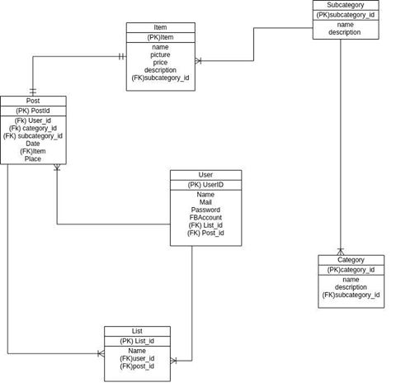

# Ownership Report

|  |  |
| --- | --- |
| ***Item*** | **Owners** |
| *System Decomposition* | *Mahmoud Mohamed Hadad* |
| Class diagrams | *Ahmed Mohamed Fekry* |
| Sequence diagrams | *Sherif Mohamed Farouk* |
| Physical Entity-Relationship Diagram | Ahmed Sayed Eid |